St Ignatius Primary School
Nursery Admissions Policy 2019- 2020

Policy Originator | St Ignatius Primary School
Person /Governor Responsible | Head Teacher
Status | Statutory
Last reviewed | Spring 2019
Ratified on

To be next reviewed | Spring 2020
Signed

Contents

- Principles

- Nursery Offer

- Application Procedure

- Over-Subscription Criteria

- Important Dates

- Waiting Lists

- Definitions

St. Ignatius Catholic Primary School Policy for Nursery Admissions

1) Principles

St. Ignatius Nursery is attached to St. Ignatius Primary School. As a Catholic school, we aim to provide a Catholic Education for all our pupils, where Catholic doctrine and practice permeate every aspect of the school’s activity. It is essential that the Catholic character of the school’s education be fully supported by all families in the school. All applicants are therefore expected to give their full, unreserved and positive support for the aims and ethos of the school.’

For the academic Year 2019/2020 we are accepting pupils born between 1st September 2015 and 31st August 2016. Children may be invited to attend Nursery from the term after they turn three if spaces are available.

Right of appeal
As nursery provision is non-statutory the school’s decision will be final and there is no formal right of appeal. However, the Headteacher will be happy to discuss any concerns parents may have about the allocation of places.

2) Nursery Offer

  - The nursery will continue to offer high quality Early Years Education, led by a fully qualified teacher and nursery nurse
  - The nursery will provide up to 39 places for each session with the staff / pupil ratio of 1:13.
  - Places will be offered in accordance with the nursery admissions policy and will comprise of the following:

- 15 hours of free education, comprising of the following hours – Monday to Friday mornings or Monday to Friday afternoons.

OR

- 30 hours of free nursery education (Monday to Friday) for those parents who are eligible. For the year 2010-2020, full time children will receive an additional free 2.5 hours per week to cover lunchtimes. This is subsidised by the school. See eligibility criteria and apply at:

https://www.gov.uk/help-with-childcare-costs/free-childcare-and-education-for-2-to-4-year-olds

In addition

The school will provide a hot meal at a price of £1.50 per day. While parents can opt to provide a healthy packed lunch, the nursery recommends the shared dining experience and eating skills that a hot school lunch encourages.

3) Application Procedure

Application forms can be collected from the school office or downloaded from the school website. The form should be accompanied by the child’s birth certificate, Baptism certificate (if available) and proof of address.

On receipt of the application, parents will be contacted and informed if there are spaces available and possible start dates will be discussed.

4. Over-subscription Criteria

- Looked after children and children who were previously looked after but immediately after being looked after became subject to an adoption, child arrangements or special guardianship order.

- Children who have a Statement of Special Educational Needs.

- Children who have an elder sibling (this includes all blood, half-, step-, adoptive and foster brothers and sisters who live at the same address) currently attending St. Ignatius Catholic Primary School in the September of the year of their admission.

- Baptised Catholic children.

- Other Baptised Christians.

- Children of other faith communities whose application is supported by a letter from their faith leader confirming membership of the faith community.

- Any other children.

TIE BREAKER:
Within each category priority will be given in the following order:
- The Governors will give top priority within each category to a child who has Exceptional Pastoral Need that can only be met at St. Ignatius and whose application is supported by the relevant Church, Education or Health Authority. The governing body will require written compelling professional evidence from an appropriate professional, such as a social worker, doctor, or priest.

- The tie breaker for all criteria is children living closest to the school measured in a straight line by Haringey Council, from the post office address point for the child’s home, to the post office address point of the school, supplied by the Royal Mail using a computerised mapping system. The tiebreak for two or more applications that live exactly the same distance from the school will be random allocation using a computerised system.

Twins or multiple births:
Where the final place is offered to a child who has other siblings applying for a place in the same school year, these siblings will also be admitted.

5) Important Dates

When places are available, applications will be considered throughout the year.

However to maximise the chance of your child being offered a place for the following academic year, please we recommend applications are submitted on or before 31st March.

New pupils will be invited to attend a Stay and Play session in May.

Welcome meetings will be held in June.

Home visits will be during the first school week in September.

6) Waiting Lists

Unsuccessful candidates will be offered the opportunity to be placed on a waiting list. This list will be maintained in order of the oversubscription criteria set out in the policy and not in the order in which applications are received or added to the list. Names will be removed from the list on the 31st December 2019 unless applicants request in writing to remain on the list.

PLEASE NOTE: THERE IS NO AUTOMATIC TRANSFER FROM NURSERY TO RECEPTION CLASS, AN APPLICATION FOR A RECEPTION PLACE WILL NEED TO BE MADE.

6) Definitions

‘Looked after children’ are those described in Section 22 of the Children Act 1989 and means any child in the care of a Local Authority or provided with accommodation by them (e.g. children with foster parents).

‘Adopted’. An adopted child is any child who has been formally adopted, having previously been in care and whose parent/ guardian can give proof of this.

‘Child Arrangements Order’. A Child Arrangements order is an order under the terms of the Children Act 1989 s.8 settling the arrangements to be made as to the person with whom the child is to live. Children ‘looked after’ immediately before the order is made qualify in this category.

‘Special Guardianship Order’. A special guardianship order is an order under the terms of the Children Act 1989 s.14A appointing one or more individuals to be a child’s special guardian(s). A child ‘looked after’ immediately before the order is made qualifies in this category.

‘Baptised’ means children or adults who have been baptised into a specific faith tradition and can produce evidence of baptism.

‘Catholic’ means a member of a Church in full communion with the See of Rome. This includes Eastern Catholic Churches. This will normally be evidenced by a certificate of baptism in a Catholic Church or a certificate of reception into the full communion of the Catholic Church.

Certificate of Catholic Practice means a certificate given by the family’s parish priest (or the priest in charge of the church where the family practises) in the form laid down by the Bishops’ Conference of England and Wales.

‘Christian’ for the purposes of this policy, means a member of one of the Churches affiliated to ‘Churches Together in Britain and Ireland’.

‘Parent’ is the person or persons who have legal responsibility for the child.

‘Resident’ - A child is deemed to be resident at a particular address when he/she resides there for 50% or more of the school week.

‘Sibling’ means brothers and sisters (including half brothers and sisters, stepchildren) within the same family unit who will still be attending the school at the point of admission.

Parish Boundaries – for the purposes of this Policy, parish boundaries are shown on the attached map.

Please collect and return application forms before specified closing date.

St Ignatius Catholic Primary School
St. Ann's Rd London, N15 6ND
Tel: 020 8800 2771
Fax: 020 8802 7156

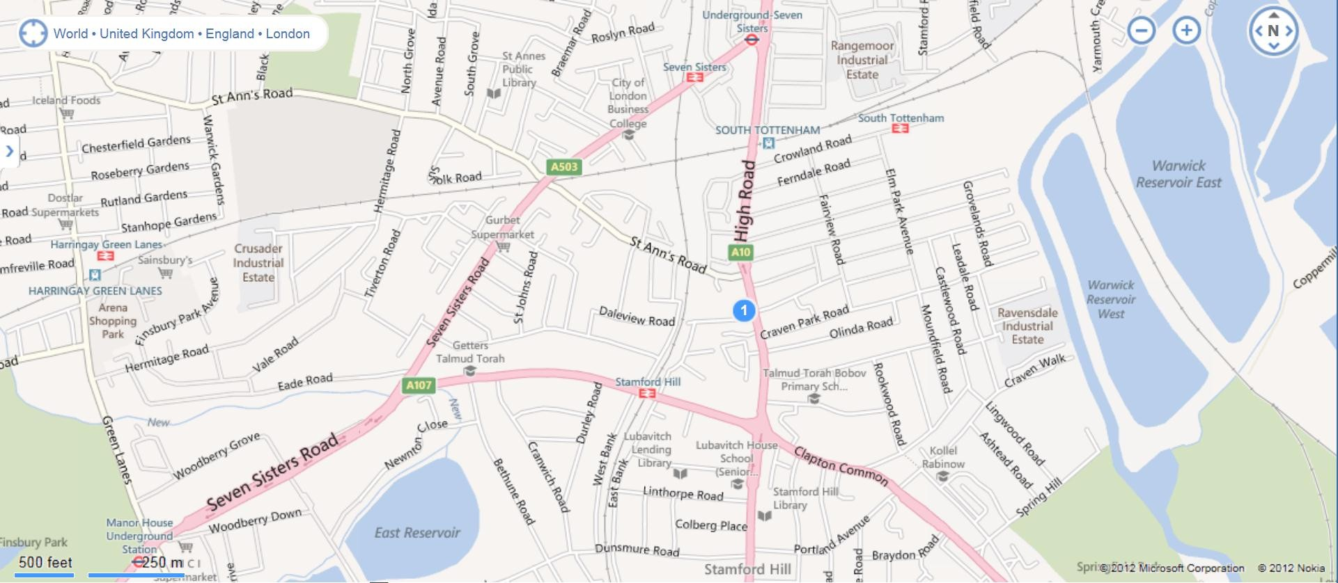
School

