Nursery Home Learning Timetable

Below is the suggested home learning weekly timetable for your child. Please look on the year group page or Tapestry for other practical ideas and examples and don’t forget to upload your pictures and videos. The timetable will be updated weekly.

Week commencing: 30th March 2020

Daily Reading | 15 mins | ‘ | Enjoy a story as a family. Cuddle up with a family member, relax, and listen to a story. Listen to Ms Donna’s story of the week on Tapestry.
Daily Phonics | 10 mins | 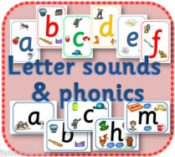 | Watch the Jolly Phonics songs on YouTube  Sound of the Week  S  Name some things that begin with S. Watch the “S” lesson on Tapestry.
Daily Mark Making | 10 mins |  | Practise naming and writing sounds in your name. Can you draw a picture of something that begins with “S”
Daily Nursery Rhyme | 5 mins |  | Incy Wincy Spider  https://www.bbc.co.uk/teach/school-radio/nursery-rhymes-incy-wincy-spider/zr4yt39  Sing daily until you can sing it by yourself.
Daily Maths | 10 mins | 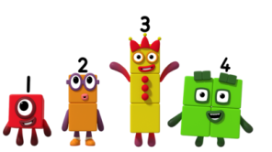 | Count to 10 (or 20 if confident to 10)  Practise recognising numbers to 10 (or 20)  Watch an episode of Number Blocks on BBC I Player or You Tube.

