Nursery Home Learning Timetable
Before 9am | Wake up | ‘ | - Eat breakfast  - Make your bed  - Get dressed by yourself!
9:00am | PE with Joe Wicks |  | https://www.thebodycoach.com/blog/pe-with-joe-1254.html  YouTube- Body Coach
9:15am | Phonics  (10 mins) | 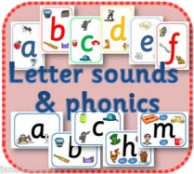 | Watch the Jolly Phonics songs on YouTube  Practise naming and writing sounds in your name. Name some things that begin with different sounds.
9:25am | Nursery Rhyme Time  (5 mins) | 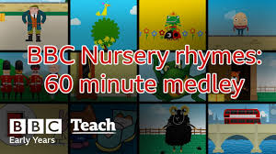 | Choose a Nursery Rhyme of the week-  https://www.bbc.co.uk/teach/school-radio/nursery-rhymes-songs-index/zhwdgwx  Sing daily until you can sing it by yourself.
9:30am | Creative Time | 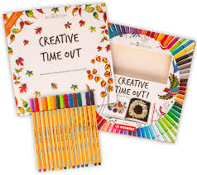 | Lego, drawing, painting, cooking, crafts, play dough.
10:45am | Fresh Air! |  | - Walk  - Yoga- Cosmic Yoga on YouTube  - Time in garden?
11:30am | Maths |  | Busy Things Maths Games on the LGFL Website. Select Nursery Games- Numbers, Shapes, Patterns etc.
12pm | Lunch |  | Help to prepare lunch
1pm | Music Time |  | Choose a favourite chart song or Go Noodle (YouTube) Song to dance around to in your living room.
1:15- 2:30pm | Free-choice Choosing time |  | Play with your toys, build with your blocks and enjoy time with your family.
2:30pm | Story time |  | Enjoy a story as a family. Cuddle up with a family member, relax, and listen to a story.
3pm | Numberblocks or Yakka Dee | 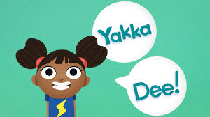 | Watch an episode of Numberblocks or Yakka Dee on Cbeebies I player or YouTube.  https://www.bbc.co.uk/programmes/b09g447t

