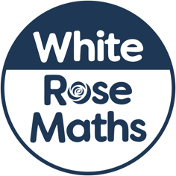

Dear Parents and Carers,

As our school must now temporarily close in response to Covid-19, we wanted to let you know about some useful homework support from White Rose Maths, whose maths scheme we use in school.
The White Rose Maths Team has prepared a series of five brand new maths lessons for each year group from Years 1-8. Every lesson comes with a short video showing you clearly and simply how to help your child to complete the activity successfully.
Finding and using the lessons
The lessons are all available on the White Rose Maths website at www.whiterosemaths.com/homelearning where you’ll also find clear instructions on exactly how access and use the right material for your child’s year group.
White Rose Maths is all about helping children to love maths by really understanding what it’s all about, so you can certainly expect to enjoy these learning sessions with your child!

Join in the daily maths!
A regular daily learning routine will help your child to learn more effectively at home, and just one 20-30 minute White Rose Maths session each day will really help your child to keep them learning and motivated. What’s more, the White Rose Maths Team will be online each weekday between 10.00 and 11.00am – great opportunities for your child to show and share their work, questions and ideas every day via any of the White Rose Maths social media channels.

#MathsEveryoneCanAtHome

[School’s own closing sentence/ signature etc]

