Reflection and Prayer Opportunities
Helping
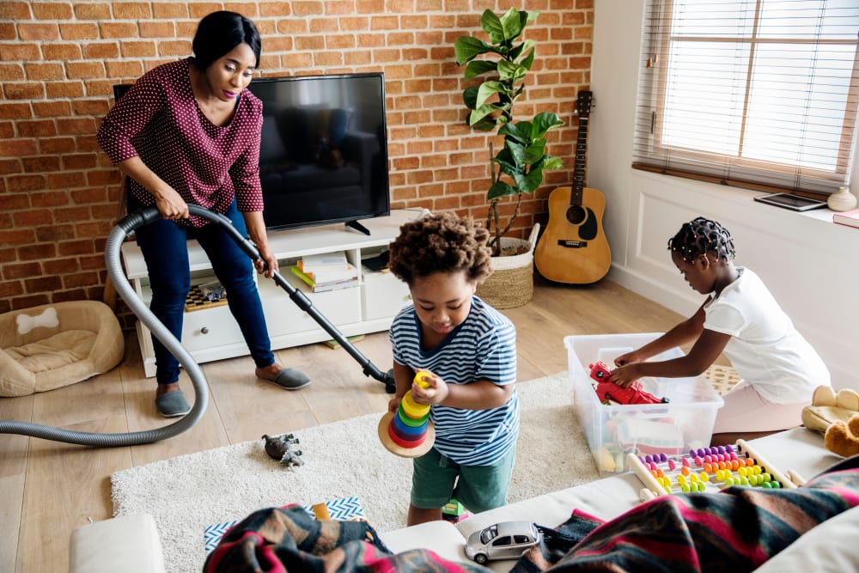
While we are all at home it is important to think about each other and how we can keep our family happy. We can read these words from the Bible and think about how they apply to our lives.

God will not forget your work and the
love you have shown him as you have
helped his people and continue to help
him. Hebrews 6:10

Activity:
Challenge

Today sit quietly and think about all the people who help you. Use your own words to say a prayer for them.
How can you show them that you are thankful?

Ask your parents what jobs you could do to help at
home. Write a list.
Each day see if you can do one job to help.

Prayer:

Guide me Holy Spirit,

Now that I am not at school I will try to find a way
to help out around the house by doing useful jobs each day.
Jesus taught us to be kind and that's how I want to be
so I'll put away my toys and I’ll lay the table for tea.
I will always make my bed, and my promises I will keep,
and I’ll pray for those I love just before I go to sleep.

Amen

