Reflection and Prayer Opportunities
Healing
At a time when many people around the world are sick, we can reflect on this story from the Bible which tells us of Jesus’ ability to heal. We trust in God’s plan and pray for the health of those around us.
Jesus Heals the Little Girl
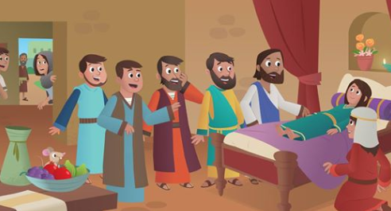
A large crowd gathered around Jesus on the shore of the lake. A man named Jairus came up to Jesus. Falling on his knees he pleaded with Jesus to heal his little girl. “My daughter is so sick. Jesus, please come to my house and place your hands on her. Please heal her so that she can live.”
Jesus and a few disciples left to go with Jairus to his home. But before they arrived a messenger met them. “Jairus’ daughter is dead. There is no reason for Jesus to come to the house. It is too late.” But Jesus ignored the comment and said to Jairus, “Don’t be afraid. Trust me!”
When they arrived at Jairus’ house, there were a lot of people crying because the little girl was dead. Jesus asked, “Why is there so much crying? The child isn’t dead; she is only sleeping.” The people thought Jesus was joking but Jesus said, “Hold her hand and say to her ‘Get up, little girl.’” They did exactly what Jesus said. The twelve year old girl immediately stood up and walked around. Her mother and father were so very happy that their daughter was now alive.
Activity:
Draw a picture of the story and write a caption. Can you write a speech bubble for some of the characters?
Prayer:
Challenge

Today make some time to sit quietly and listen to God.
Use your own words to pray for the people in our world who need healing.

Loving Father,
We pray for our school community and for all those we know who need healing in their lives. Keep them safe and give them strength through your love.
Amen

