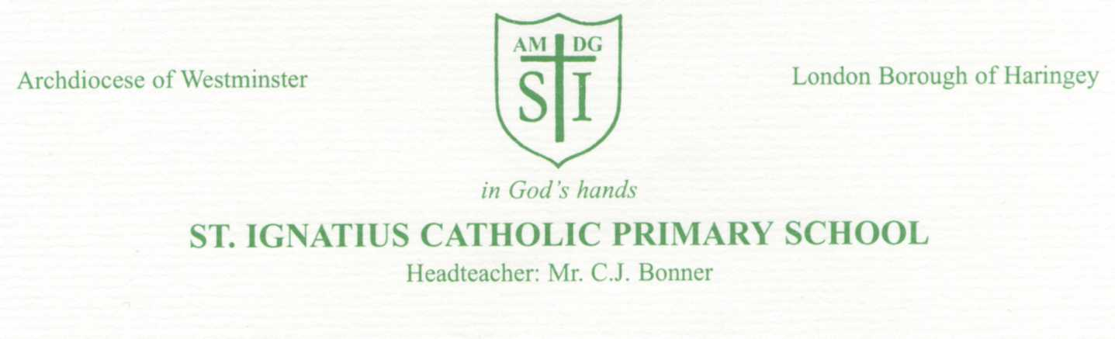

Thursday 27th February 2020

Dear Parents,

Re: Coronavirus
https://www.gov.uk/guidance/wuhan-novel-coronavirus-information-for-the-public

Many of you will have heard about the Coronavirus outbreak and you may be concerned about the impact of this on the health of your children. As a school, we are keeping ourselves aware of the changing situation, in order to assess any potential risk.

The advice we are following is regularly updated and I would encourage you to follow the links on the Public Health England (PHE) website:
https://www.gov.uk/guidance/wuhan-novel-coronavirus-information-for-the-public
This advice offers unbiased information to anyone who may be worried.

Please note that any pupil who has travelled to or been in direct contact with anyone from a Coronavirus affected area will be asked to remain at home, to prevent the potential spread of the virus. This is in accordance with PHE guidance. If this is the case, please inform the school immediately.

In the meantime, we continue to follow our ‘staying healthy’ procedures in school.
We are reminding children of the importance of washing their hands thoroughly with soap and water and covering their mouths when they cough.

We have displayed posters around school, informing everyone of how to stop viruses spreading.

If your child is unwell with a temperature and /or cough, please consider keeping them at home to stop any infection spreading.
It is very important that you inform us of your child’s illness so that it can be recorded and authorised.
If you are worried and need further medical advice, please call NHS 111.

If you would like to discuss this issue further, please see Mr Bonner, Ms Curran or Ms Allan.

Yours faithfully

Mr Bonner

Head Teacher

