Home Learning for the Easter Holidays- Year 1
Week commencing 6th March:
St Ignatius Home Learning Weekly Timetable
Activity | Resource/Access | Activity
30 minutes Daily Reading  Audio Story: https://www.storynory.com/the-monkey-who-loved-chocolate/  By Dianne Bates | Individual reading books | Please continue to read every day with your child. You can find books allocated to your child on active learn. Login to Active Learn and click on ‘My Stuff’ to find your allocated reading books. Don’t forget to look at the inside cover of the book to practise the sounds and words that you will find inside the book.  Please listen to this audio story with your child.
Daily Spelling/Phonics | activelearnprimary.co.uk  (find login details inside the cover of your green book – same as lgfl login)  busythings.co.uk  (find login details inside the cover of your green book – same as lgfl login)  Weekly spellings:  https://www.youtube.com/watch?v=deUTRW1MTgg  Spellings: o_e sound.  Phone home o_e  - they  - called  - bone  - home  - rose  - stone  - joke  - phone  - froze  - envelope  Challenge words (year 2 common exception):  behind child | Login to Active Learn and click on ‘My Stuff’ to find phonics games you can play.  Key stage 1 > Year 1 setup > English > Phonics programme  Children can select phases 2, 3 &4 or phase 5 to access a variety of games that will help with reading and writing words.  Practise your tricky words using the spelling sheet format:  Read, cover, write, check x3.  Can you put the words in a sentence?
Daily Times Tables | https://www.youtube.com/watch?v=JyCr0IgbYcI  Counting by 2s song for practise.  https://www.youtube.com/watch?v=9C4EN7mFHCk | https://mathsframe.co.uk/en/resources/resource/306/Maths-Fishing-Multiplication  Fishing game – choose the two times tables option.
Daily Sumdog  Maths -Problem of the Week | Log in to Sumdog to see allocated maths challenges for your child.  whiterosemaths.com  (no login needed)  Home learning > Year 1 > Week 1  Home learning > Year 1 > Week 2 | Continuation of last weeks maths.  Use the videos and questions on white rose maths. One lesson per day is advised.  Estimation challenge:  Gather several different containers. Which container will have the greatest capacity? Which container will hold the least amount? Write down your predications. Next, estimate how many cups it will take to fill the different containers. Count and record. Was your predications correct?  See Maths challenge on the year group page.
RE | RE Home Learning Page | Please see the activities set on the RE Home Learning Page.
Physical Challenge  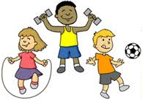 | https://www.youtube.com/watch?v=uNrIB6O_Abo | Cosmic yoga. It is called ‘Saturday Morning Yoga’ but is suitable for any day of the week! It is Easter related as it includes lots of bunny hops. An enjoyable way to get your child active.
Creative challenge | 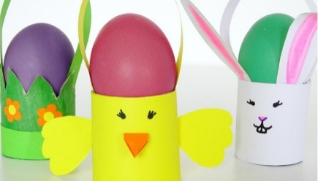  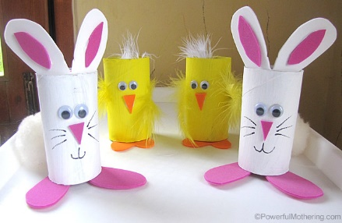  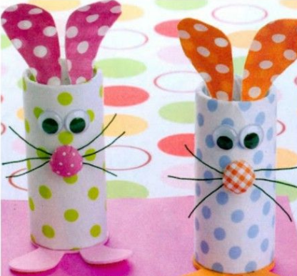 | Using old toilet roll cylinders, create your own Easter animals or baskets for your eggs. You can cut these in half to make them smaller. To make the feet, ears or handle for your basket, use materials around the house such as cereal boxes. Decorate as you wish, the brighter the better!  You can upload your creations to our DOJO stories to share with your class.  Another art idea: Boil and egg, leave it to cool and colour in or paint an Easter design. You could even place them in your toilet roll creations.
ICT Challenge | https://www.bbc.co.uk/bitesize/topics/zymykqt/articles/zc4x6sg  BBC bitesize | BBC Bitesize website have lots of useful information about what a computer is, what we can use them for and how to be safe. This could be especially useful, and we are using them more often than usual. Children will need an adult’s supervision on this site to help them read the content. Games are included to reiterate their learning.
Cooking Challenge | Chocolate nests. | All you will need:  -Bun cases  -Plain milk chocolate  -Cornflakes or rice krispies  -Mini eggs to decorate.  Melt the chocolate in a big bowl in the microwave. Pour in rice krispies or cornflakes. Mix until all covered in chocolate. Fill the bun cases, place 2 or 3 eggs on the top and place in the fridge. Don’t forget to lick the spoon.  Share creations on DOJO.
Music Challenge | https://www.youtube.com/watch?v=IEey4LZLeGw | I’m A Spring Chicken.  A lovely song to get the children in the Easter spirit.  A song that the whole family can join in with. Can you make up a dance to go with the song?
First News Quiz  See activity on year group pages! | School Website | Look at the quiz on your year group page.

