Home Learning for the Easter Holidays- Year 2
Week commencing 6th April:
St Ignatius Home Learning Weekly Timetable
Activity | Resource/Access | Activity
30 minutes Daily Reading  Audio Story: Hansel and Gretel | Individual reading books  https://www.storynory.com/hansel-and-gretel-2/ | Please continue to read every day with your child.  Please listen to this audio story with your child.
Daily Spelling/Phonics | Practice 10 common exception words:  Child  Children  Christmas  Class  Climb  Clothes  Door  Even  Every  everybody  You could practice these spelling words in Sum Dog challenge games. | Practice writing these words and then use the correct spelling of the word in a sentence. For example: We have 27 children in my class.  Your log in details are in your homework books. Please contact us on Dojo message if you are finding it difficult to log in.
Daily Times Tables | Continue practicing 2s and 5s times tables. Try to become fluent with quick snappy responses.  Use these bitesize games and song to practice! | Ask a family member to test you. Use a 1 minute timer to see how many times tables sums you can answer. You can keep a chart to check how well you are doing every day. Start with the 10x table then move on to 2s and then 5s.  https://www.bbc.co.uk/bitesize/topics/zqbg87h/articles/zc7ygdm
Daily Sumdog  Maths -Problem of the Week | Place value practice challenge  Division practice challenge  Continue to use sum dog for free choosing. | Challenge has been set up on Sumdog. Take your time and you do not need to answer all the questions in one day.  Set up on Sumdog  See Maths challenge on the year group page.
RE | RE Home Learning Page | Please see the activities set on the RE Home Learning Page.
Physical Challenge | We will be learning about living things and their habitats in Topic. Choose an animal from a specific habitat and use the youtube sounds to move like that animal.  For example: I will be a shark in the ocean habitat and use this video to help me move:  https://www.youtube.com/watch?v=uUU_BkBBAZ0 | Ocean habitat video:  https://www.youtube.com/watch?v=uUU_BkBBAZ0  Woodland habitat video:  https://www.youtube.com/watch?v=OdIJ2x3nxzQ  Rainforest habitat video:  https://www.youtube.com/watch?v=8myYyMg1fFE  Desert habitat video:  https://www.youtube.com/watch?v=fvRkWO5g2HE  Please feel free to have a browse yourself and see what you can find!
Creative challenge | We will be learning about living things and their habitats in Topic.  You could create a habitat using:  Cereal boxes  Shoe boxes  A jar (for ocean habitat)  Paper  You could choose:  Polar habitat  Ocean habitat  Woodland habitat  Rainforest habitat  Urban habitat  Desert habitat | https://www.bbc.co.uk/bitesize/topics/zx882hv - explore the different habitats.  Here are some examples:  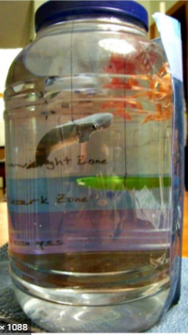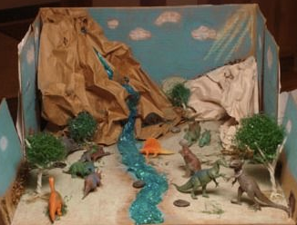  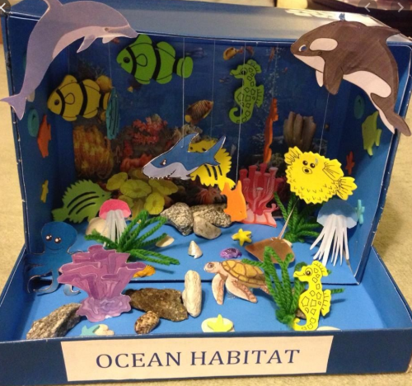
ICT Challenge | Explore these zoo’s live web cams. You could write some notes in your blue homework books.  How do they move?  What do they eat?  Can you tell which one is the adult or the child? What are their differences or similarities?  Which habitat does your chosen animal belong to? | https://zoo.sandiegozoo.org/live-cams  http://www.houstonzoo.org/explore/webcams/
Cooking Challenge | These delicious biscuits take just 30 minutes to make and you only need 5 ingredients:  - 200g unsalted butter, softened  - 200g golden caster sugar  - 1 large egg  - ½ tsp vanilla extract  - 400g plain flour, plus extra for dusting | https://www.bbcgoodfood.com/recipes/easiest-ever-biscuits
Music Challenge | Sing along to the ‘Spring Chicken’ song. | https://www.youtube.com/watch?v=IEey4LZLeGw
First News Quiz  See activity on year group pages! | School Website | Look at the quiz on your year group page.

