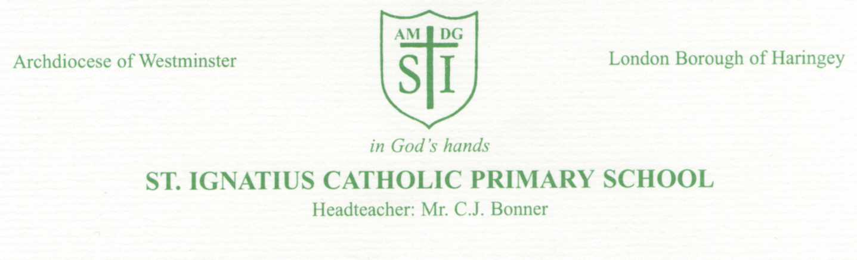
16th March 2020
Dear Parents,
We are currently monitoring the situation regarding the spread of Coronavirus very closely.
The present government directive is that schools remain open. In order to do this we must do everything we can to keep our school community healthy.
Minor illnesses Normally, in order to maintain our good attendance record we are happy for children with low level coughs, sniffles, colds, headaches, aches or pains to come to school. However, given these very different circumstances, if your child is unwell, even with a minor illness, they should be kept at home until they are fully recovered. Please inform the school of their absence via telephone or email admin@st-igs.haringey.sch.uk Please be assured that your child’s absence will be authorised during these exceptional circumstances.
If your child presents as unwell in school, we will contact you as they must be collected immediately.
If your child(ren) or any member of your family are unwell, or you need further advice in relation to this situation, including self-isolating, please continue to follow the government’s latest advice at: https://www.nhs.uk/conditions/coronavirus-covid-19/
It is important to note also that there are several children in our school who currently have chicken pox. As you will be aware, this is a contagious illness and children need to be kept at home for the recommended period and until they are no longer infectious.

Hopefully, by taking these measures we can all help to limit the spread of illness to both the children and adults in our school community. We can only do this effectively, if we have your support to make vital decisions to keep your child at home if they are unwell.

Currently, a number of our school staff are absent, due to illness, and are following government guidance to self-isolate. This means there may be some disruption to your child’s timetable. We will continue to do all we can to keep our school open, however, this may not be possible should our staffing levels fall to such a level that it is not possible to ensure the safety of all pupils.

Thank you for your patience as we work together to respond to what is a fast-changing and challenging situation.

Yours sincerely,

C J Bonner

Mr C J Bonner Head teacher

Please see below / overleaf for our Online Learning provision

Re: Online Learning

In the event that schools may be advised to close, in an effort to slow down the spread of the current coronavirus outbreak, we have been preparing activities and tasks for your child to access at home.

We are preparing now so that we can show / teach our pupils, how to access our online learning sites and also support any parents who need help to access our learning activities.
Many companies are currently updating their resources to make them more accessible for pupils to use at home.
It is good practice for the pupils to be accessing these resources even if school remains open during these exceptional times.

We will continue to send Parentmail text messages to you to update you with new information, or to direct you to areas of our website, including our online learning section.
If you are not receiving Parentmail messages, please inform Mrs Hibbert at the office so she can resolve this issue for you.
If you have changed your mobile number, you need to let the school office know so that we can change this on our system and thereby communicate with you.

We are hopeful that all our pupils will be able to access online resources through access to a PC, laptop, tablet, or mobile phone. If your child is unable to access any of these, please inform us so we can help you to support them in other ways.

Online activities
There are several resources that your child can access on line through our website
https://stignatiuscatholicprimary.co.uk/key-information/online-learning
You will also receive this link in a Parentmail message.
They will need their log in details that are in the front of their homework diaries or workbooks – this log in is the same for lgfl account/ ActiveLearn and Sumdog.
Lgfl account can be accessed via lgfl.net or through the lgfl tab on the top right hand tab of our website.
The online learning page will be updated regularly with useful websites/resources/information/apps to support home learning.
There will be ideas for creative home learning too and the weekly newspaper for children ‘First News’ will be posted each week for the children to enjoy reading (KS2).
We have put links to the main websites that the children access at school, so should you forget how to access these please check this page to find out.

School pack of activities
If schools are advised to close, your child may also bring home a selection of activities, possibly including:
Reading - extra books, SATs booklets ( Y2 Y6) Phonics activities, Year group word lists – read and spell
Writing - Extra paper, Spelling practice sheets
Maths – Number bond practice, times table practice
.
You may also be able to help your child with creating their own project around a topic of interest to them e.g. animals, countries, space, football, history topic - using pictures from catalogues / magazines / papers

If you have any questions or would like to discuss any of the content of this letter, please speak with your child’s teacher. Alternatively, you may speak to Mr Bonner, Ms Curran or Ms Allan.

