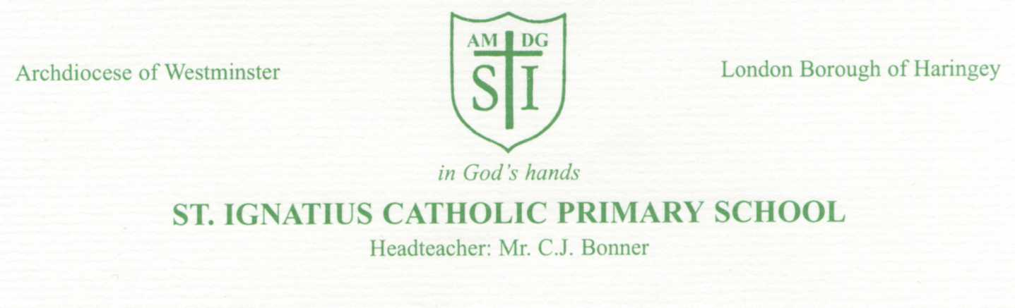
11th March 2020
Dear Parents / Carers Re: Coronavirus
The current situation with the COVID-19 virus is one that is developing and changing on a daily basis. We continue to follow all advice and guidance provided to us by Public Health England (PHE).
This week the Government launched an action plan setting out what the UK as a whole has done to tackle the Coronavirus (COVID-19), and what it plans to do next. The action plan can be found here: https://www.gov.uk/government/publications/coronavirus-action-plan
At St Ignatius, we are trying to do all we can to take a professional and practical approach to ensure the health and safety of all of our pupils and staff. It is now more important than ever that we all pull together to support each other and our broader school community. If Coronavirus continues to spread it is thought that the symptoms in children are likely to be mild. However, if the virus reaches our community, it may have an impact on staffing levels. This means we may have to partially close the school by sending some classes home and not running breakfast and after school clubs. If Public Health England directs us to close the whole school we will act promptly to notify you.
In the meantime, good hygiene remains the most important and effective way we can reduce the spread of any infection and we continue to encourage our pupils and staff to: - wash their hands with soap and water for at least 20 seconds - use tissues for coughs, colds and sneezes, remembering the ‘catch it, bin it, kill it’ slogan.
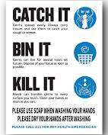 | If your child is unwell, please follow the usual procedure in school for reporting any absence.  Also let us know If you have any information regarding you, your child or a member of your immediate family in your household, in relation to COVID-19, or if you are self- isolating.  A government helpline for advice has been set up for staff, parents and young people to use if there are any queries about the virus and the impact on education.  Updates on COVID-19: https://www.gov.uk/coronavirus  Phone: 0800 046 8687 Opening hours: 8am to 6pm (Monday to Friday)  Email: DfE.coronavirushelpline@education.gov.uk

We thank you all for your help and support throughout this difficult time.
Yours sincerely,
C.J. Bonner
Head Teacher

